CovidSIMVL Technical Report #3

September 4, 2020

**THE BASIC SCHOOL SCENARIO EXTENDED**

In Technical Report #2, a basic scenario was laid out, for 3 groups of 10 students each, in a school with 6 teachers, according to the following schedule:

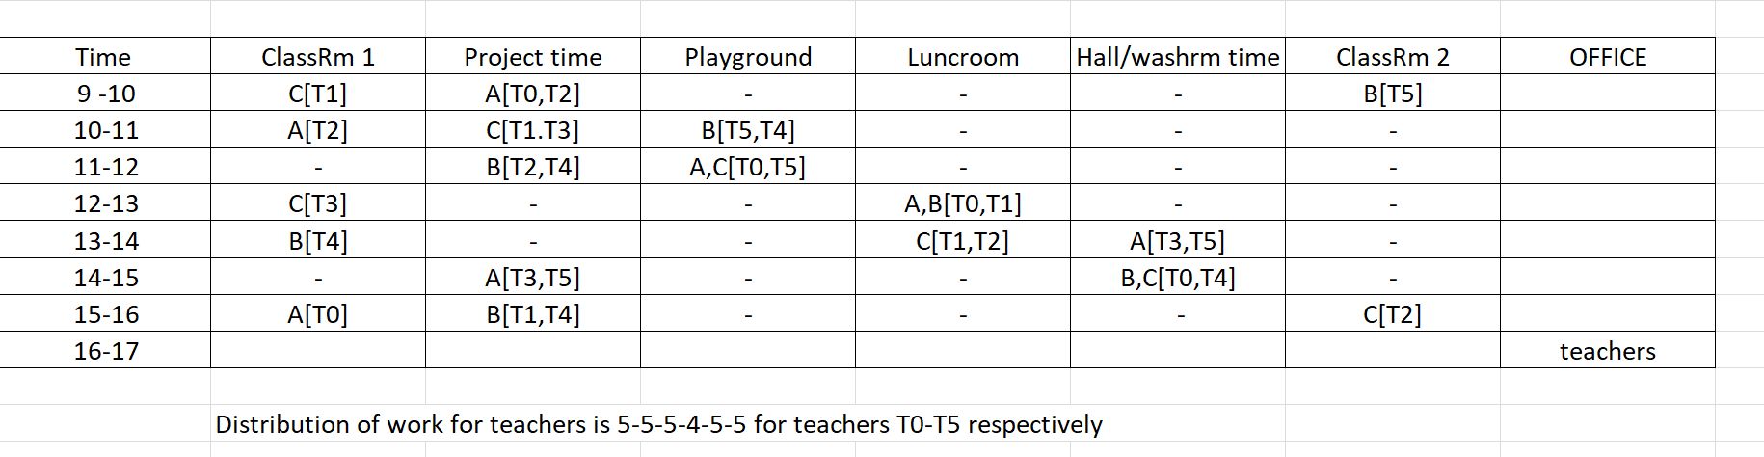

This was implemented in:

2020.08316MVL1509famKey.html using

FKschoolDATA.30S6T.csv and

VLone.csv

These can be found in [www.github.com/ecsendmail](http://www.github.com/ecsendmail) in one of the project repositories

This basic scenario has 7 Universes as shown above, but no family grouping, and the mingle factors as persons moved around was not given careful attention. Furthermore, there are no places outside school except HOME, and in particular, no HIGH-MINGLE universes such as a bar, dance floor, indoor party, and no VULNERABLE population spaces such as a LONG TERM CARE unit.

This next extended model includes them, and we call this the LTC/BAR Scenario.

**The LTC/BAR SCENARIO**

This is considerably more complex that the BASIC/SCHOOL Scenario, and includes family structures and different groups of persons in terms of their social roles.

We begin by enumerating the social roles (total 100)

1. Students 3 x 10 in groups A, B, C
2. Teachers 6
3. Grandparents 7
4. LTC residents 28 of which 10 are associated with families
5. LTC staff 14
6. High-mingle site (Bar) staff 10
7. Spouse community work 5

The family structures are complex and we have created 19 families in this community. Before we enumerate them, the general structure of a family is:

1. Heads of family (one or two) with social roles
   1. May be two-person eg Teacher + LTC staff
   2. May be single-person
   3. May be grandparents only (two-person with social role)
2. May have children (0 to 4)
3. May have multi-generational (grandparents not heads of family)
4. May have LTC resident as part of family (grandparents, aunts)

The 19 families have been carefully defined and structured with the use of analog tools (poker chips, pins, paper clips, checkers pieces, anchor bolts, etc) – photos found at end of this document. The enumeration of the families follows, in no particular order:

F0 LTC(S), BAR, A, C LTC(S) – staff, BAR – bar staff, A,C – student groups A,C

F1 T, BAR, LTC(R), C T – teacher, LTC(R) – LTC resident

F2 T, LTC(S), LTC(R),G,B,C G – grandparent

F3 LTC(S),BAR,B,C,LTC(R),LTC(R)

F4 G,G,B Grandparents as head of family with one grandchild

F5 T,BAR,A,C

F6 T,LTC(S),A,A,B,C,G,G,LTC(R) biggest family unit – four kids, 2 grandparents, one LTC res

F7 BAR, LTC(S), A,B,B

F8 BAR,LTC(S),A,C

F9 BAR,LTC(S),A,C

F10 BAR,S,G,A,C Bar worker, spouse, grandparent, two children

F11 LTC(S), S Long Term Care staff, spouse – no kids

F12 LTC(S),S

F13 LTC(S),S, LTC(R) this will be among the visitors to LTC

F14 LTC(S), S, LTC(R), LTC(R)

F15 T,LTC(S), G, LTC(R)

F16 BAR,LTC(S),A,B,B three kids, two in same group

F17 BAR, LTC(S), A,B,C

F18 T,B, LTC(R) single parent (teacher), one child, one LTC resident

This microcosm is tightly coupled between the workers who are teachers, LTC staff, and BAR workers (BAR being a place-holder for high-mingle spaces). With so many being in the same family units, this scenario may have a higher rate of crossover transmission between the school and LTC unit not just because of frequenting the high-mingle bar, but also because of the family units, which have most LTC workers with children, and/or spouses who are teachers or work in the HIGH-MINGLE bar.

**SCHEDULING THE LTC/BAR/SCHOOL/HOME**

Some general scheduling principles:

1. The HOME is a unique Universe in which transmission only happens between family members. The simulation space is 800 x 600 but might contain 100 persons at times. Depending on the mingle factors, the odds of any 3 persons in the same family affecting one another can be very small (as experienced in simulation trials of population vs size vs mingle factor) unless the sizes are quite large – and this setting depends on the odds that one wants to set on there being within family transmission in one hour.
2. It is expected that if a family member is a LTC RESIDENT, that family head (at least one) and child (zero to one) will visit during the day. Of course, this is one of the parameters that can be changed for different trials of this scenario.
3. The scheduling for LTC staff of 14 is 7+4+3 for 7am-3pm, 3pm-11pm, 11pm-7am.
4. The scheduling for BAR staff of 10 is 10am-6pm 4 staff, 6pm-12 midnight 6 staff
5. Teachers, spouses, LTC staff are scheduled to be visitors to the HIGH-MINGLE universe during the hours 12 to 12, including at leas one of the grandparents, the LTC staff as they fit in
6. The students go home, and there is no venue for their physical interaction. This keeps the simulation “pure” in the sense that school is the only place for transmission between students, and from the student-teacher interactions. The other spaces are:
   1. BAR – hot spot for transmission
   2. LTC – vulnerable Universe for transmission to be avoided

The actual schedule generated will be implemented in the file:

FKschoolLTCbar.csv

The school Universe will have to lose Hallway/Washroom to allow for BAR and LTC. Otherwise the school schedule will be amended as follows: